Course _______Specialist______ Year __12_____

Student name: ________________ Teacher name: ________________

Date: 17 June Weds p3 (Advo)

Task type: Response

Time allowed for this task: _____45______ mins

Number of questions: _____7______

Materials required: Calculator with CAS capability (to be provided by the student)

Standard items: Pens (blue/black preferred), pencils (including coloured), sharpener, correction fluid/tape, eraser, ruler, highlighters

Special items: Drawing instruments, templates, notes on one unfolded sheet of
A4 paper, and up to three calculators approved for use in the WACE examinations

Marks available: __42____ marks

Task weighting: _12___%

Formula sheet provided: Yes

Note: All part questions worth more than 2 marks require working to obtain full marks.

Q1 (3.3.5- 3.3.6) (2 & 3 = 5 marks)
Consider a car A that has an initial position vector km and moving with a constant velocity of km/h.
- Determine the position vector in 5 hours from now.

Solution
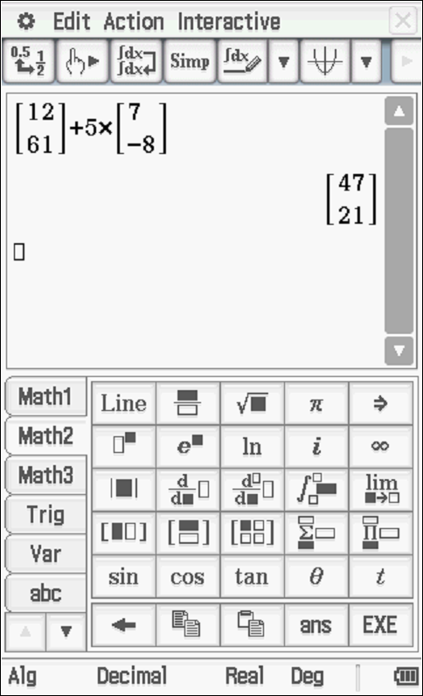

Specific behaviours
multiplies velocity by time
states position vector

Consider a second car B that has an initial position km and a constant velocity of km/h.

- Determine if the two cars collide and if they do the position vector of this point of collision and the time it occurs.

Solution
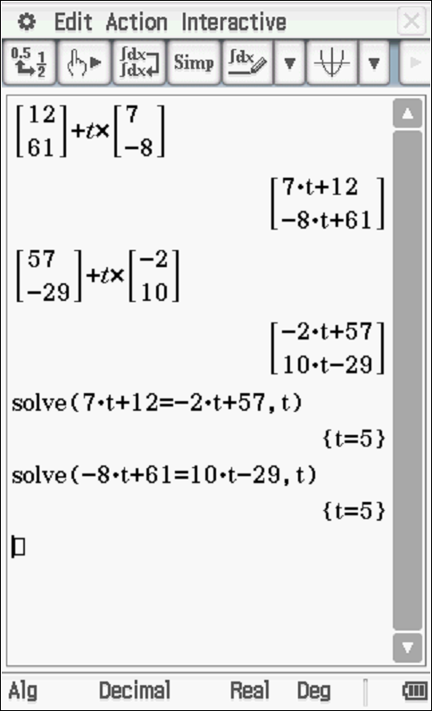
Collide at (47,21) Km

Specific behaviours
obtains expression for position vectors in terms of time
solves for i components
solves for j component and states pt of intersection

Q2 ( 3.3.1, 3.3.3) (3 & 2 = 5 marks)
Consider the two lines
- Determine the point of intersection, if any.

Solution
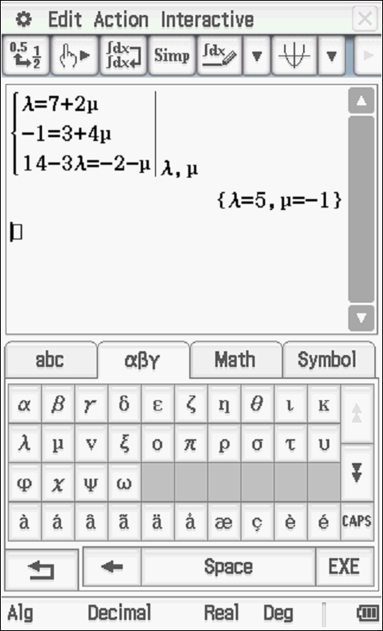
Intersect at (5,-1,-1)

Specific behaviours
uses two parameters
sets up three simultaneous equations
states pt of intersection

- Determine to the nearest degree the acute angle between the two lines.
(Consider the plane that contains both lines)

Solution
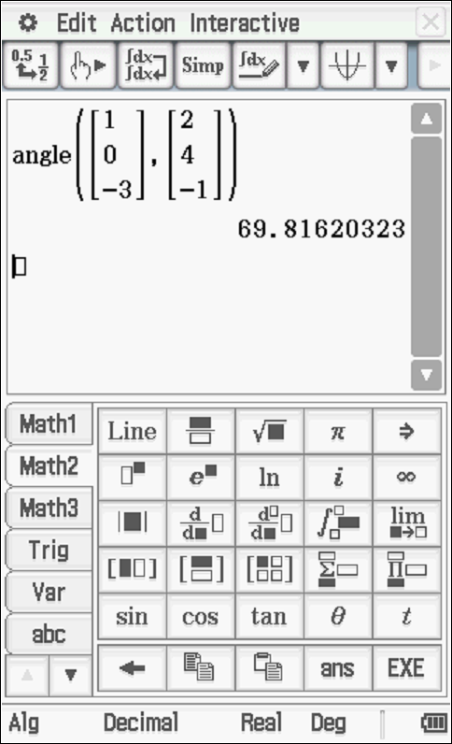

Specific behaviours
uses vectors parallel to lines
states acute angle between lines

Q3 (3.3.8) (2, 3 & 3 = 8 marks)
Consider a plane that contains the point and has a normal vector .
- Determine the vector equation of the plane.

Solution
Specific behaviours
uses dot product with normal
right hand side correct scalar

- Determine the point of intersection of the line with the plane above.

Solution
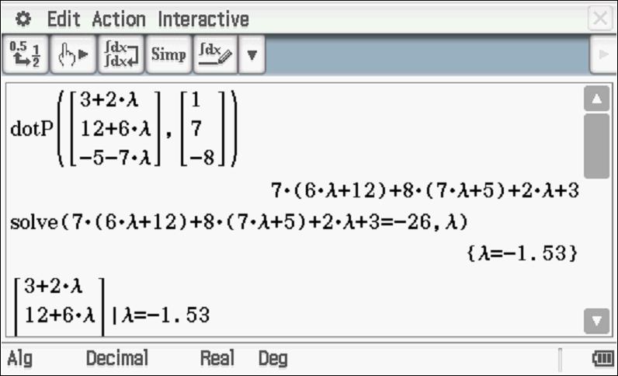
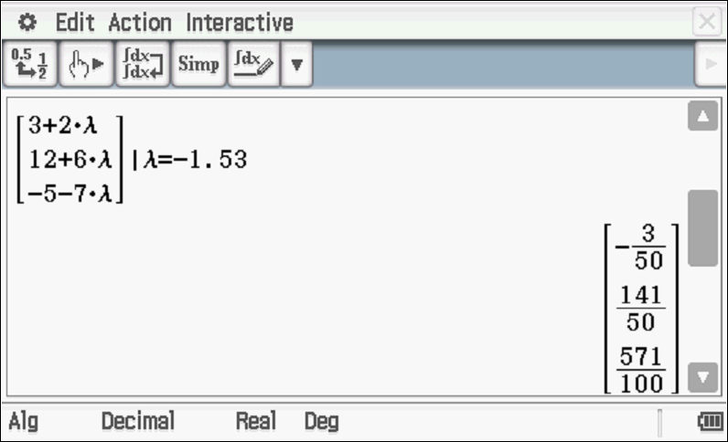
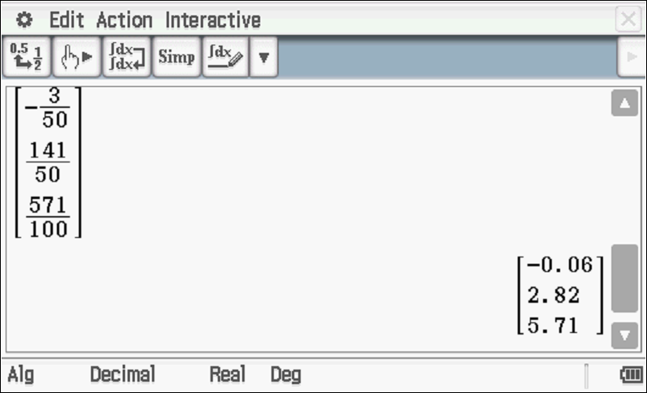

Specific behaviours
subs line into plane equation
uses dot product and solves for parameter
states pt of intersection, allow approx. decimal

- Determine the distance of point from the plane above.

Solution
Choose any point on plane (0,0,26/8)

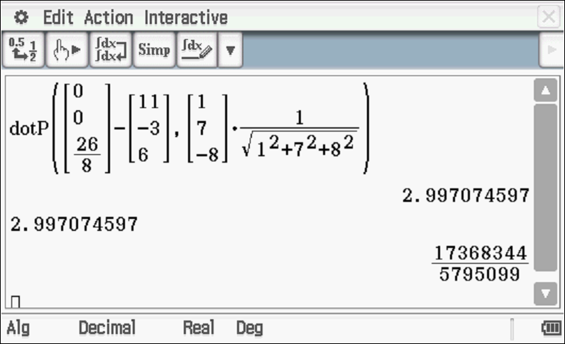
OR
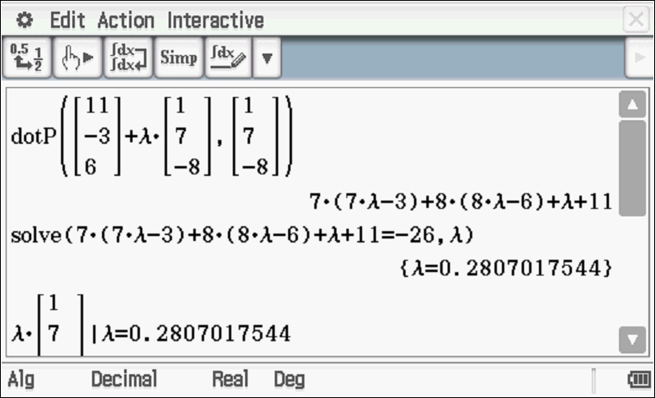
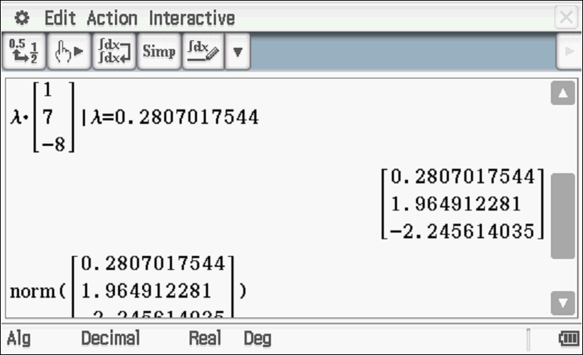
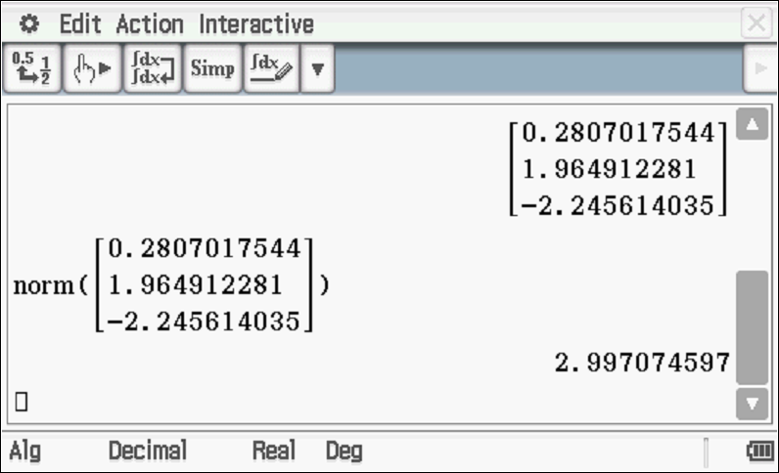
Specific behaviours
chooses any point on plane OR line parallel to normal through point
uses dot product
states approx distance

Q4 ( 3.3.9-3.3.10) (3 & 3 = 6 marks)
- Solve the following system of linear equations. Working must be shown.

Solution
Specific behaviours
eliminates one variable from two equations
eliminates two variables from one equation
solves for all three variables

Consider the constants in the system below.
- Determine all the value(s) of such that:
- There will be an unique solution
- There will be infinite solutions
- There will be no solutions
`

Solution
Specific behaviours
obtains row with two variables eliminated
determines values for infinite solns
determines values for unique and no solution

Q5 (3.3.11 – 3.3.15) (3 & 3 = 6 marks)
Consider an object moving with acceleration at time seconds. The initial velocity is and initial displacement .
- Determine the position vector at time seconds.

Solution
Specific behaviours
integrates to find velocity with a vector constant
integrates to find position with a vector constant
solves correctly for both vector constants

- Determine the distance travelled in the first 10 seconds.(One decimal place)

Solution
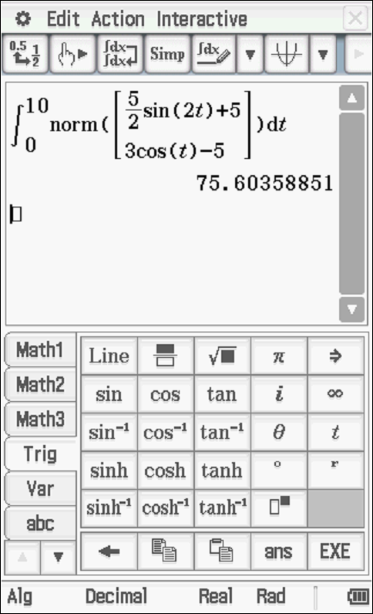
Distance =75.6 metres

Specific behaviours
uses magnitude of velocity(shown)
states integral
states distance to one decimal place

Q6 (3.3.15) (3 & 2 = 5 marks)

Consider an aircraft with position vector at time hours. At the top of a building stands an antenna with the position vector of the highest point being .
- Determine the times the aircraft is less than 100 km from the top of the antenna.

Solution
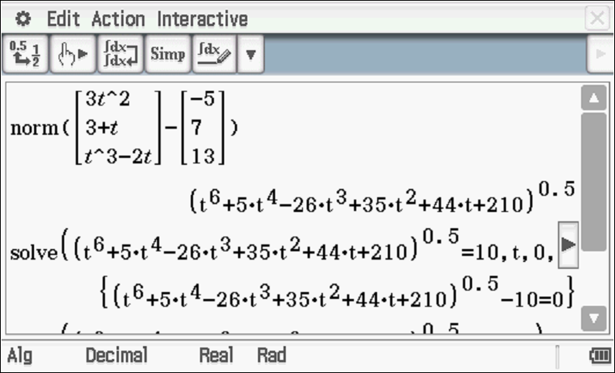
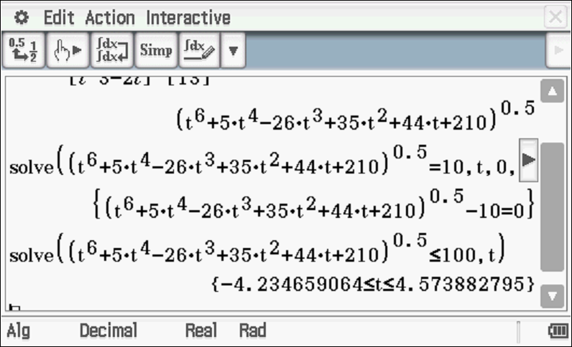
Time between zero and 4.57 seconds

Specific behaviours
uses vector subtraction
determines expression for distance apart
solves for less than 10 km and states non negative values of time

- Determine the closest approach of the aircraft and the time it occurs.

Solution
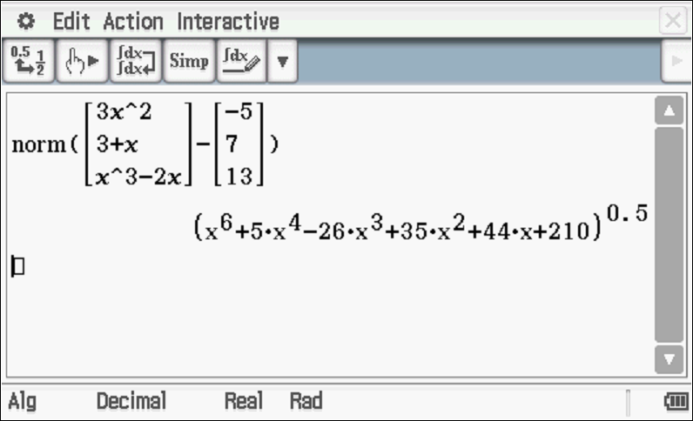

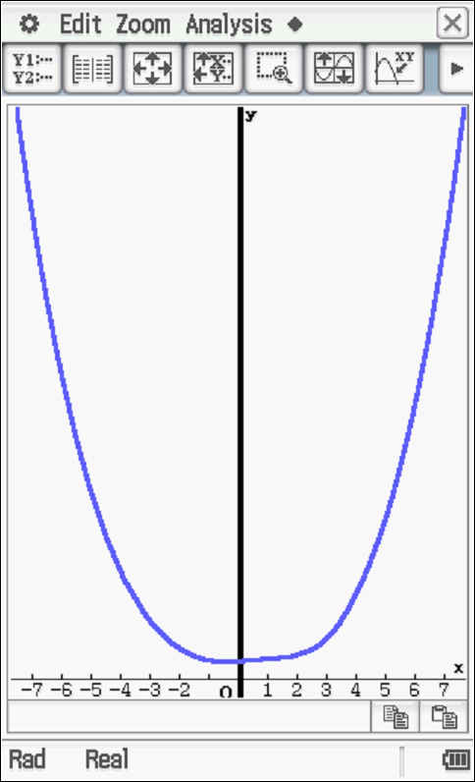
Min distance at t=zero seconds

Specific behaviours
graphs or uses fmin of expression for distance apart from part a
states t=0 & 14.5 km

Q7 (3.3.15) (4 & 3 = 7 marks)

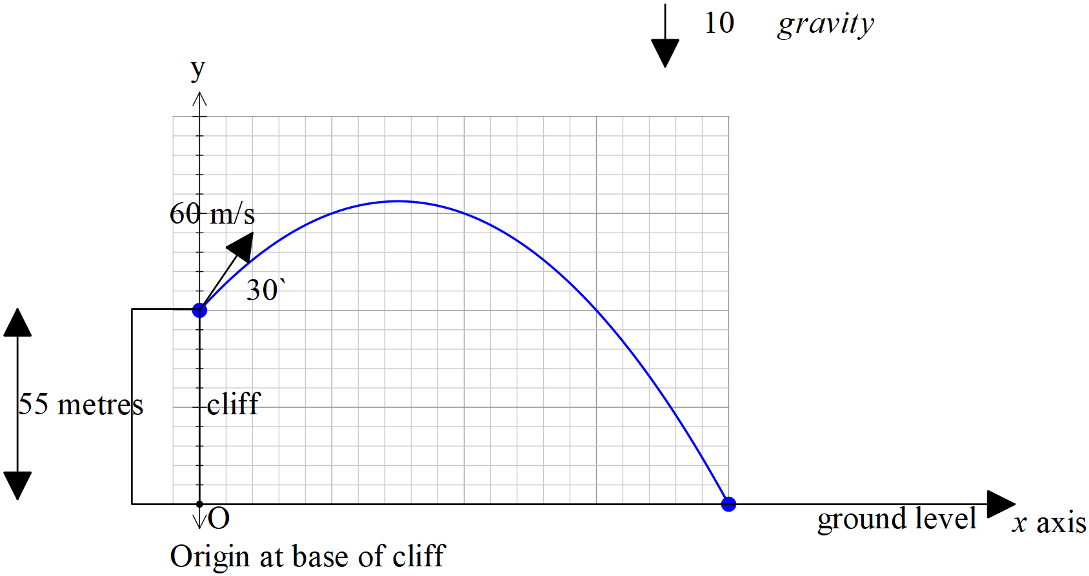

Consider a football that is kicked off the top of a cliff of height 55 metres with an initial speed of 60 m/s at an angle of with the horizontal. The acceleration due to gravity is .
- Show using vector integration how to determine the exact cartesian equation of the path using the base of the cliff as the origin.

Solution
Specific behaviours
integrates acceleration and solves for vector constant
integrates velocity and solves for vector constant
obtains expression for t in terms of x
obtains exact cartesian equation

- Determine the time, one decimal place, taken to hit the ground and the horizontal distance of this point from the base of the cliff.

Solution
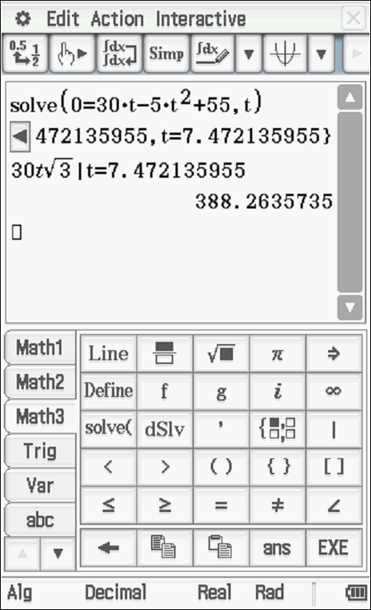

Specific behaviours
equates y parametric equation to zero
solves for time to one decimal place
states approx. horizontal distance

End of test

